**Cyber Security**



**Encryption**

Mir Hussain

023-19-0106

Submitted to Sir. Zakaria

**Q:** Decrypt the following plaintext by using Caesar cipher.

1) Trviri tzgyvij riv hlzkv vrip kf tirtb

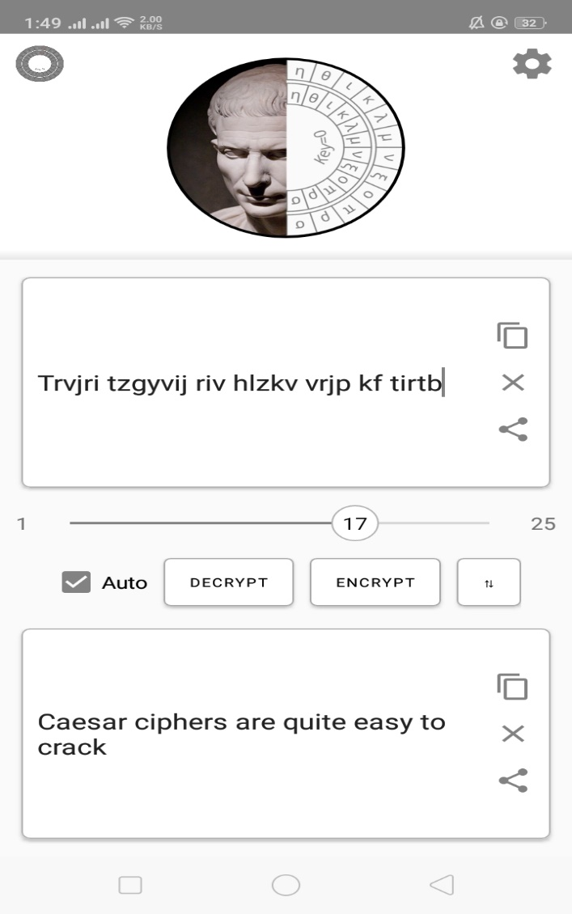

2) N fr ns jnlmyym xjrjxyjw

**Q:** What key do we need to make "CAESAR" become "MKOCKB"?

**Ans:**  We have to right shift 9 time CAESAR to get MKOCKB.

**s**